EQUITY RESEARCH REPORT
Eli Lilly and Company
NYSE: LLY |Sector: Healthcare / Pharmaceuticals |Aug 18, 2026
RATING | CURRENT PRICE | TARGET PRICE | IMPLIED RETURN
HOLD | $1,180.16 | $1,063.06 | (9.9%)

This report was prepared independently as a self-directed equity research portfolio project. All figures are sourced from Eli Lilly's SEC filings, company guidance and public market data as cited throughout (see the companion Excel model for full source citations).

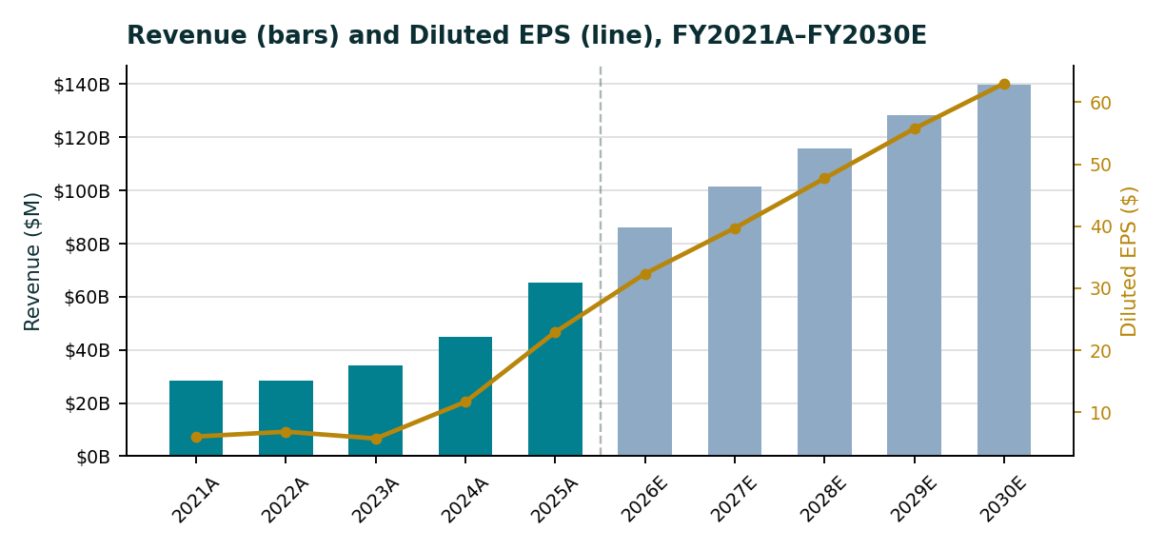
Investment Snapshot
- GLP-1 franchise expansion is the core investment driver: Mounjaro and Zepbound grew from zero to 65% of FY2025 revenue, making the franchise the central pillar of LLY’s growth thesis.
- DCF points to broadly fair value: The DCF indicates shares are approximately 2.1% below fair value while a straightforward peer-multiple approach appears significantly more bearish. However, the comps-based discount is overstated because peers have materially lower growth profiles.
- Valuation supports a HOLD: The blended target price of $1,063 implies a 10% downside supporting a HOLD rating. This reflects a view that LLY is fully valued rather than fundamentally overvalued with further upside dependent on continued execution and sustained premium valuation.

Executive Summary
- Eli Lilly and Company has undergone a significant transformation in just four years, driven primarily by the rapid expansion of its GLP-1 franchise. Mounjaro and Zepbound serving diabetes and obesity markets went from negligible revenue in 2021 to contributing 56% of FY2025 revenue or approximately $36.5 billion of the company’s $65.2 billion total. This exceptional growth has supported a substantial valuation of re-rating with LLY trading at roughly 32x forward earnings that is well above the 17x large-cap pharma peer median and its market capitalization surpassing $1 trillion.
- Our valuation anchored by a DCF and supported by a growth-adjusted trading comparables analysis yields a blended target price of $1,063 per share, representing approximately 10% downside from the current share price of $1,180. Therefore, it is assigned a HOLD rating. This reflects valuation rather than a negative view of the business: Lilly’s operating performance, execution and long-term growth outlook remain strong, but the current share price appears to already incorporate much of that expected success.
- The central valuation debate is the gap between fundamental value and headline multiples. Our DCF, which incorporates Lilly’s stronger revenue growth and margin expansion, places the shares broadly around fair value at roughly 2% from the current price. By contrast, an unadjusted peer-multiple approach implies a substantially greater downside but does not account for the significant growth differential between Lilly and its peers. With growth incorporated, Lilly’s 1.4x PEG ratio appears reasonable rather than excessively supporting a premium valuation. The HOLD rating therefore reflects risk-adjusted valuation rather than a negative fundamental view with competitive pressure, working-capital requirements and uncertainty across the five-year forecast remaining key considerations.
Key Statistics
Metric | Value
Current Price (Aug 17, 2026) | $1,180.16
52-Week Range | $685.15 - $1,249.45
Diluted Shares Outstanding | 891.7 million
Market Capitalization | $1.05 trillion
FY2025A Revenue | $65.2 billion
FY2026E Revenue Guidance (company) | $85.0 - $87.0 billion
Forward P/E | 32.4x
Beta | 0.51
Street Consensus Rating | Buy (20-23 of 25 analysts)
Street Consensus Target | $1,305

Company Overview
Eli Lilly and Company established in 1876 and headquartered in Indianapolis; Indiana is a global pharmaceutical company focused on the discovery, development, manufacturing and commercialization of human medicines. Unlike many large-cap pharmaceutical companies that report across multiple operating segments, Lilly operates as a single reportable segment. Therefore, its business is more appropriately analysed by therapeutic area and individual product franchise rather than by geographic or divisional reporting lines.
Business Lines
- Cardiometabolic Health- Lilly’s largest and fastest-growing therapeutic area are led by Mounjaro and Zepbound (tirzepatide, a dual GIP/GLP-1 agonist). The portfolio also includes established insulin therapies such as Trulicity, Humalog and Basaglar as well as the oral SGLT2 inhibitor Jardiance.
- Oncology- A broad cancer portfolio comprising Verzenio, Cyramza, Erbitux, Jaypirca, Retevmo and the newer Inluriyo.
- Immunology- Key therapies include Taltz, Olumiant, Omvoh and Ebglyss serving a range of inflammatory and immune-mediated conditions.
- Neuroscience- Includes Emgality and Kisunla (donanemab), Lilly’s treatment targeting Alzheimer’s disease.
GLP-1 franchise: The rapid expansion of Mounjaro and Zepbound has fundamentally reshaped Lilly’s revenue profile. Mounjaro had not launched in 2021 while Zepbound was not yet on the market but by FY2025, the two products generated approximately $36.5 billion in combined revenue exceeding Lilly’s total company-wide revenue in 2021. This franchise represents the primary driver of the bullish investment thesis, but its increasing contribution also creates meaningful product and franchise concentration risk.
Industry & Competitive Landscape
Lilly operates within the highly competitive global pharmaceutical market with its most important competitive battleground currently being the GLP-1/incretin market for diabetes and obesity treatments. Its primary rival is Novo Nordisk, the long-standing market leader behind Ozempic and Wegovy. In 2026, Novo has encountered greater competitive pressure including pricing headwinds, pipeline challenges, and market-share losses to Lilly’s tirzepatide-based therapies. At the same time, Novo’s newly launched oral GLP-1 treatment has quickly gained traction in the U.S. capturing many new prescriptions within its category following its January 2026 launch. The competitive landscape highlights an important point for the investment thesis: the overall GLP-1 market continues to expand rapidly, but market share is actively contested and can shift meaningfully between competitors.
Beyond Novo Nordisk, Lilly competes with a broader group of diversified large-cap pharmaceutical companies including Pfizer, Merck and AbbVie. While these peers may not compete directly with Lilly across individual products, they are relevant benchmarks for R&D productivity, capital allocation, pipeline strength and overall portfolio quality. These broader pharmaceutical peers also form the peer group used in the trading comparables analysis in this report.
A defining characteristic of the pharmaceutical industry is the recurring patent-cliff cycle as major products eventually lose exclusivity and face generic or biosimilar competition. Lilly is already experiencing this transition across older products such as Trulicity and Humalog which have moved beyond their peak growth periods and are gradually declining as newer therapies gain share. This shift in the product portfolio is an important theme in the company’s broader financial outlook.

Financial Analysis
Historical Performance (FY2021A-FY2025A)
Lilly’s financial performance underwent a significant inflection beginning in FY2023, driven by the rapid ramp-up of Mounjaro and the subsequent launch of Zepbound. Revenue growth moved from essentially flat levels in FY2021-FY2022 to 44.7% in FY2025, while operating margin increased from 22.4% to 40.3%. The combination of accelerating revenue and expanding margins points to meaningful operating leverage rather than growth being driven solely by higher sales.

($M except per share) | FY2021A | FY2022A | FY2023A | FY2024A | FY2025A
Total Revenue | 28,318 | 28,541 | 34,124 | 45,043 | 65,179
Revenue Growth % | — | 0.8% | 19.6% | 32.0% | 44.7%
Gross Margin % | 74.2% | 76.8% | 79.2% | 81.3% | 83.0%
Operating Margin % | 22.4% | 25.0% | 18.9% | 28.6% | 40.4%
Net Margin % | 19.7% | 21.9% | 15.4% | 23.5% | 31.7%
Diluted EPS | $6.12 | $6.90 | $5.80 | $11.71 | $22.95

The decline in FY2023 operating and net margins was primarily driven by elevated R&D and business-development expenses rather than a weakening of Lilly’s core operating performance. This highlights the potential volatility in annual pharmaceutical margins where acquisitions, licensing deals and other strategic investments can create significant year-to-year fluctuations.
Working capital provides an important counterpoint to Lilly’s strong growth profile. Days Inventory Outstanding increased from 194 days in FY2021 to 454 days in FY2025 reflecting substantial inventory and manufacturing buildout to support surging GLP-1 demand. Over the same period, capital expenditures rose from $1.3 billion to $7.8 billion, an increase of nearly 500%. While these investments support future growth, they also represent a significant cash-flow requirement and execution consideration for the business.

5-Year Forecast (FY2026E-FY2030E)
FY2026E is based on Lilly’s latest management guidance which has been raised twice during 2026 from $80.0-83.0 billion in February to $82.0–85.0 billion in April and ultimately to $85.0–87.0 billion in August. The sequence of upward revisions provides a strong indication of sustained operating momentum and management’s ability to forecast effectively.
For FY2027E–FY2030E, the projections are based on our own model assumptions. Revenue growth is expected to moderate from 18% to 9% annually as the GLP-1 franchise moves toward a more mature growth phase along with operating margins continuing to expand but at a gradually slower pace.

($M except per share) | FY2026E | FY2027E | FY2028E | FY2029E | FY2030E
Total Revenue | 85,971 | 101,446 | 115,648 | 128,370 | 139,923
Revenue Growth % | 31.9% | 18.0% | 14.0% | 11.0% | 9.0%
Operating Margin % | 42.0% | 43.0% | 44.0% | 45.0% | 46.0%
Net Margin % | 33.5% | 34.5% | 36.0% | 37.5% | 38.5%
Diluted EPS | $32.35 | $39.71 | $47.71 | $55.72 | $62.99

These projections represent our base-case assumptions rather than Wall Street consensus estimates. The accompanying Scenario Analysis illustrates the potential range of outcomes with FY2030E revenue spanning approximately $105 billion in the bear case to $176 billion in the bull case. The primary drivers of this range are the pace of GLP-1 growth normalization and the extent to which margin expansion is sustained versus reaching a plateau.
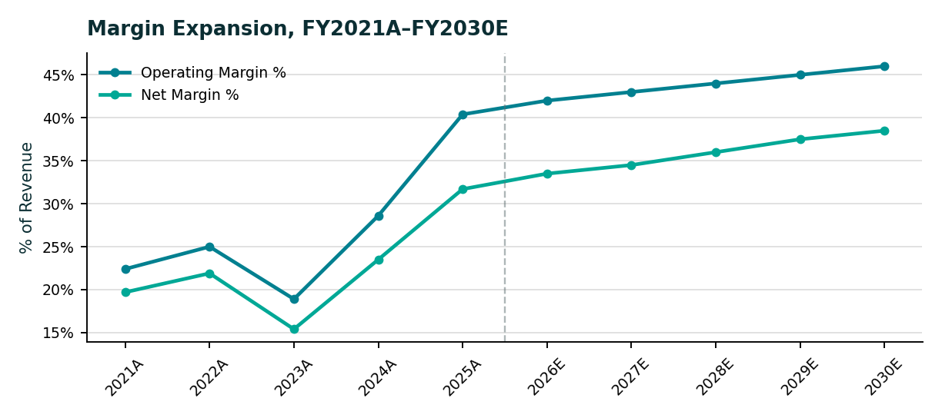

Valuation
Weighted Average Cost of Capital
We estimate Lilly’s WACC at 7.1% based primarily on its cost of equity. The 7.25% cost of equity is derived using CAPM combining a 4.70% risk-free rate with a 0.51 beta and a 5.0% equity risk premium. The after-tax cost of debt is 4.38% that is based on a 5.38% pre-tax borrowing cost derived from the yield-to-maturity of Lilly’s 2049 bond and adjusted for an 18.5% effective tax rate. Given Lilly’s relatively low debt burden compared with its market capitalization, the capital structure is weighted approximately 96% toward equity and 4% toward debt.
One key assumption warrants closer scrutiny: LLY’s 0.51 beta appears unusually low relative to the stock’s recent price volatility with the shares ranging from approximately $685 to $1,249 over the past 52 weeks because a lower beta reduces the CAPM-derived cost of equity, it also lowers WACC and all else equal, raises the DCF-implied valuation. We therefore do not treat the CAPM output as definitive but instead, the accompanying Sensitivity Analysis explicitly tests alternative beta and WACC assumptions to assess how robust the valuation is to this input.

Discounted Cash Flow
Our DCF values Lilly by discounting unlevered free cash flow (NOPAT + D&A − CapEx − investment in net working capital) over the FY2026E–FY2030E forecast period, followed by a Gordon Growth terminal value. We assume a 3.0% perpetual growth rate reflecting a mature long-term growth rate modestly above expected nominal GDP growth. This approach recognizes Lilly’s current demand-driven growth cycle while assuming that double-digit expansion is not sustainable indefinitely as the business matures.

DCF Output | Value
Sum of PV of Explicit FCF (FY26E-30E) | $150.5 billion
PV of Terminal Value | $914.6 billion
Enterprise Value | $1,065.2 billion
Less: Total Debt | ($42.5 billion)
Plus: Cash & Investments | $7.3 billion
Equity Value | $1,030.0 billion
Implied Share Price | $1,155.03
Implied Upside / (Downside) | (2.1%)

The terminal value accounts for approximately 86% of total enterprise value in our DCF. While a high terminal-value contribution is expected for a company still experiencing elevated growth, it also highlights an important valuation risk: most of Lilly’s implied value depends on long-term assumptions beyond the explicit forecast period rather than on near term cash flows that can be assessed with greater certainty.
Trading Comparables
We compare Lilly against four large-cap pharmaceutical peers: Novo Nordisk, Pfizer, Merck and AbbVie.
Company | Ticker | P/E | EV/EBITDA
Eli Lilly | LLY | 32.4x | 31.5x
Novo Nordisk | NVO | 14.3x | 9.5x
Pfizer | PFE | 18.6x | 7.5x
Merck | MRK | 15.1x | 28.7x
AbbVie | ABBV | 19.0x | 16.7x
Peer Median (excl. LLY) |  | 16.8x | 13.1x

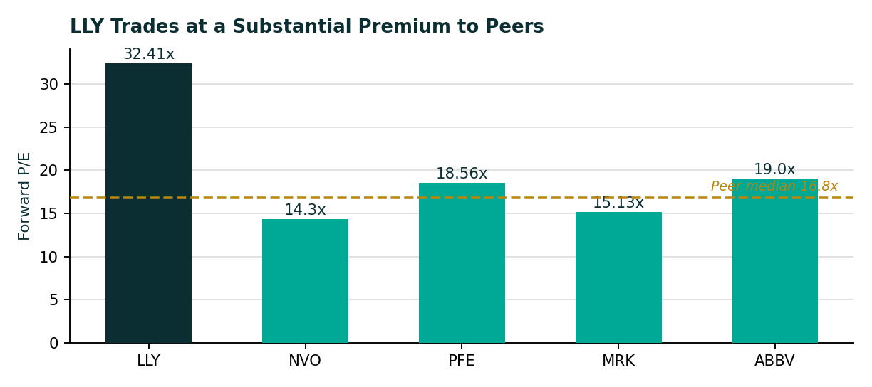
Applying the 16.8x peer median P/E to Lilly’s FY2026E earnings produces an implied value of approximately $544 per share, well below both the current price and DCF valuation. We assign this approach only 15% weight because the peer group grows at low-single-digit rates versus 30%+ expected growth for Lilly. A more relevant growth adjusted measure is Lilly’s 1.4x PEG ratio, which suggests its premium valuation is largely supported by superior growth rather than excessive multiple expansion.

Blended Valuation & Sensitivity
We assign 85% weight to the DCF and 15% to the more conservative trading comps approach, resulting in a blended target price of $1,063.06 or approximately 9.9% downside from the current share price. Given the DCF’s sensitivity to WACC and terminal growth assumptions, we also evaluate a range of valuation outcomes rather than relying on a single point estimate.

Scenario | WACC | Terminal Growth | Implied Price
Bear | 8.14% | 2.0% | $777.83
Base | 7.14% | 3.0% | $1,154.66
Bull | 6.14% | 4.0% | $2,233.69

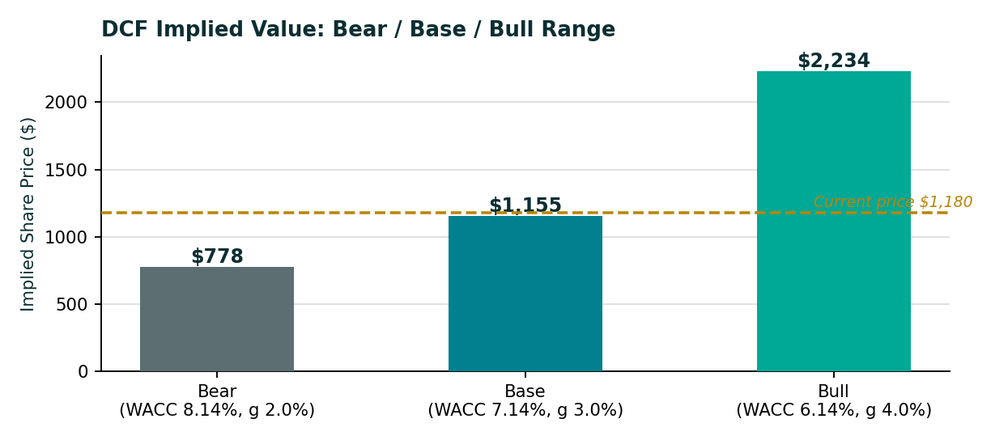

The wide valuation range of $778 to $2,234 from relatively modest changes in WACC and terminal growth is itself a key finding. It highlights how heavily Lilly’s current $1,180 valuation depends on sustained long-term execution and assumptions about future growth rather than representing a narrow range of low-risk outcomes.

Investment Thesis

Bull Case
The upside scenario assumes Lilly’s GLP-1 franchise continues to outperform expectations supported by Foundayo’s oral formulation expanding the addressable patient base and Retatrutide providing a potential next-generation growth driver. Lilly’s two guidance increases in 2026 further reinforce the company’s execution track record. Sustained growth and strong execution could justify continued premium valuation multiples driving the share price materially above our base case.
Base Case
We expect the GLP-1 franchise to keep growing but at a more measured pace as patient penetration rises and competition from Novo Nordisk and new entrants intensifies. Pricing and access pressures including the Medicare GLP-1 Bridge Program launched in July 2026 could also weigh on realized net pricing despite continued volume growth. Under these assumptions, our DCF places LLY near intrinsic value with the blended target indicating modest downside as growth expectations normalize.
Bear Case
The key risks are intensifying competition and execution challenges. Novo Nordisk’s oral GLP-1 has already gained significant U.S. prescription share showing that Lilly’s market leadership is not guaranteed. Meanwhile, rising inventory days and heavy manufacturing investment increase execution risk. Declining legacy products such as Trulicity, Humalog and Basaglar provide limited diversification, leaving Lilly particularly exposed if GLP-1 growth slows materially.

Catalysts
- Retatrutide and pipeline catalysts could extend Lilly’s growth runway beyond current expectations.
- International expansion of Mounjaro and Zepbound offers additional upside as penetration increases across underdeveloped ex-U.S. markets.
- Further guidance upgrades would reinforce the positive momentum established by two upward revisions in 2026.
- Foundayo adoption will be a critical indicator of the potential scale of the oral GLP-1 market.

Key Risks

- Competitive risk: Novo Nordisk and other GLP-1 entrants could capture market share faster than expected, particularly as the emerging oral GLP-1 segment remains highly competitive and unsettled.

- Concentration risk: More than half of Lilly’s revenue is now tied to its GLP-1/incretin franchise creating greater exposure to product-specific, competitive and regulatory risks than a more diversified pharmaceutical portfolio.

- Working capital and execution risk: Inventory days have risen to 454 while capital expenditures have increased nearly 500% since 2021 highlighting the operational demands of rapid manufacturing expansion. Any execution issues could place further pressure on cash flow and growth capacity.

- Pricing and policy risk: Government initiatives such as the Medicare GLP-1 Bridge Program may broaden patient access while putting pressure on realized net prices. Continued U.S. drug pricing reforms add further uncertainty to Lilly’s long-term revenue and margin outlook.

- Valuation risk: Lilly’s 32x forward P/E combined with a low beta assumption leaves the stock vulnerable to both execution disappointments and broader growth stock de-rating during market or rate shocks. Our sensitivity analysis highlights this exposure with modest changes in WACC or growth assumptions producing significant swings in implied value.

- Patent and franchise-decline risk: Mature products such as Trulicity, Humalog and Basaglar are already in decline, and the pace of erosion could accelerate as patent pressure and newer therapies reshape the portfolio. This makes the assumed rate of legacy-product decline an important valuation variable.

Conclusion & Recommendation

Eli Lilly’s recent performance has been exceptionally strong with revenue more than doubling over two years and operating margins expanding by approximately 18 percentage points. Management has also strengthened its credibility through two guidance increases in 2026 reinforcing the company’s strong execution and operating momentum.
The central question is how much of Lilly’s exceptional fundamentals are already embedded in its valuation. Our analysis indicates that the market has largely priced in the company’s strong growth profile: the DCF arrives at a value close to the current share price while the growth-adjusted PEG approach suggests Lilly’s premium multiple is broadly justified by its superior earnings growth rather than being excessive.
We rate LLY HOLD with a blended target price of $1,063.06 representing approximately 9.9% downside from the current $1,180.16 price. Existing shareholders can reasonably maintain their positions given Lilly’s strong execution and potential catalysts while prospective investors may benefit from waiting for a more favourable entry point following competitive, pricing or broader market-driven volatility.

